Go to **START EE;B(PDM)**

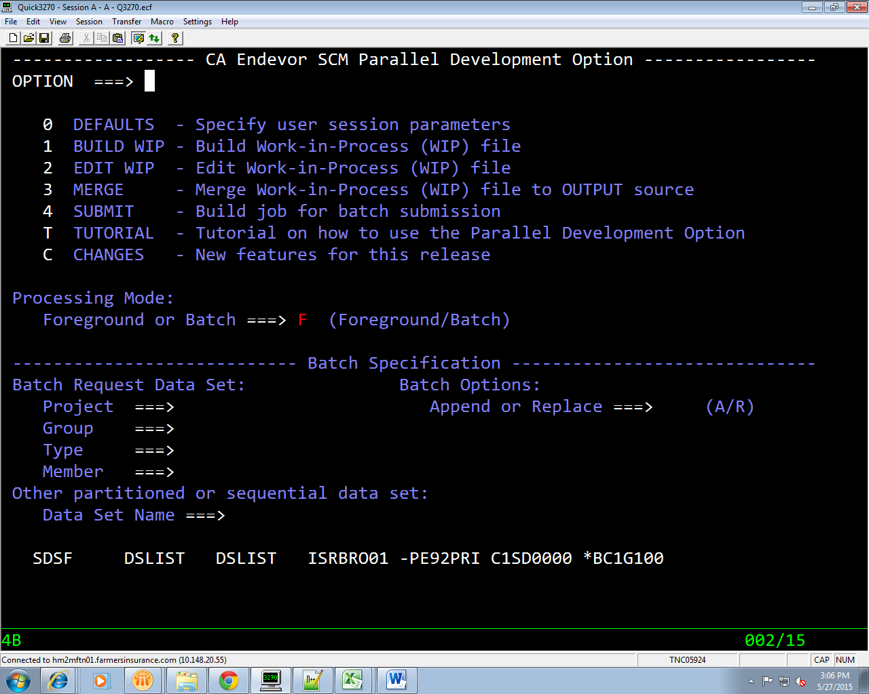

**Press 1** (Build WIP)

**Also give the dataset for PDM comparision say** CLST.D678301.PDM

**Give no of derivation s as** 1

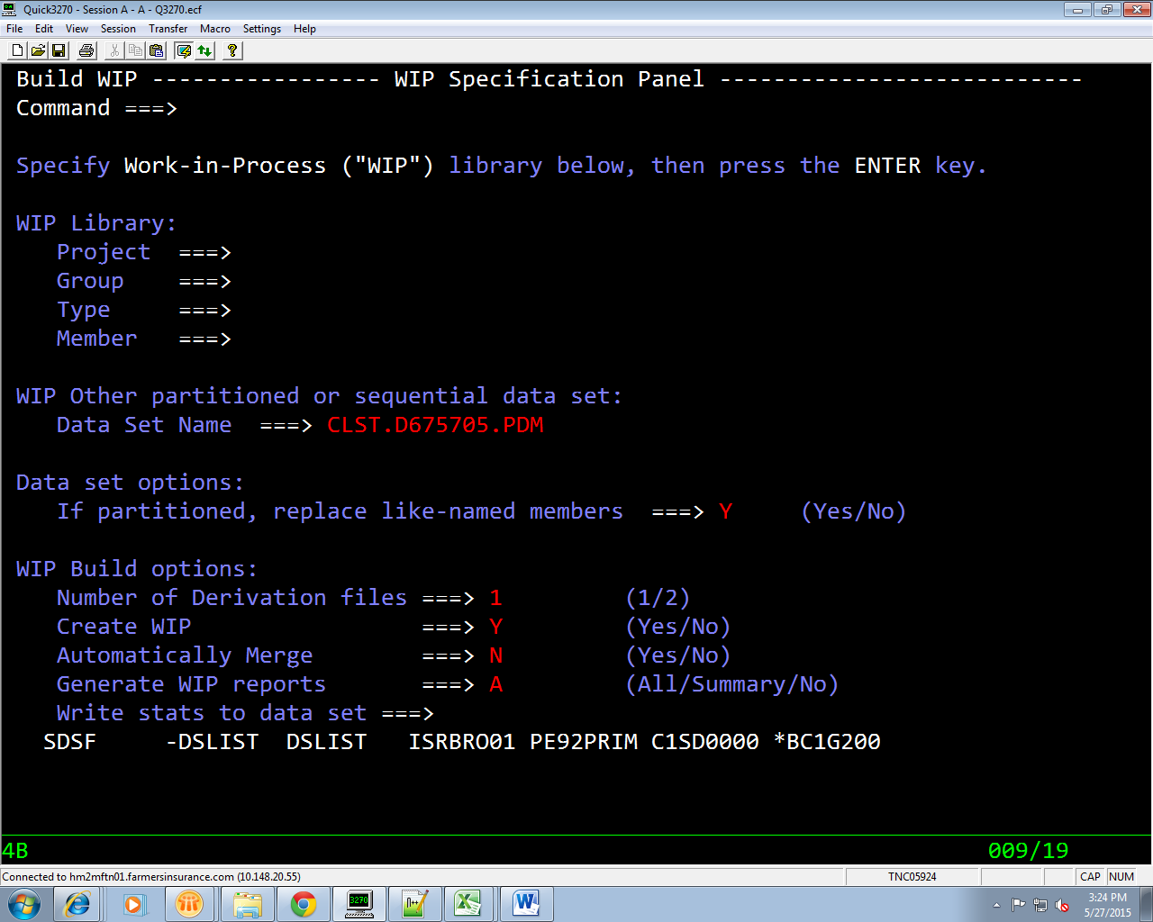

Give Root element here **mostly PROD element**

**Build Root from ===>** E

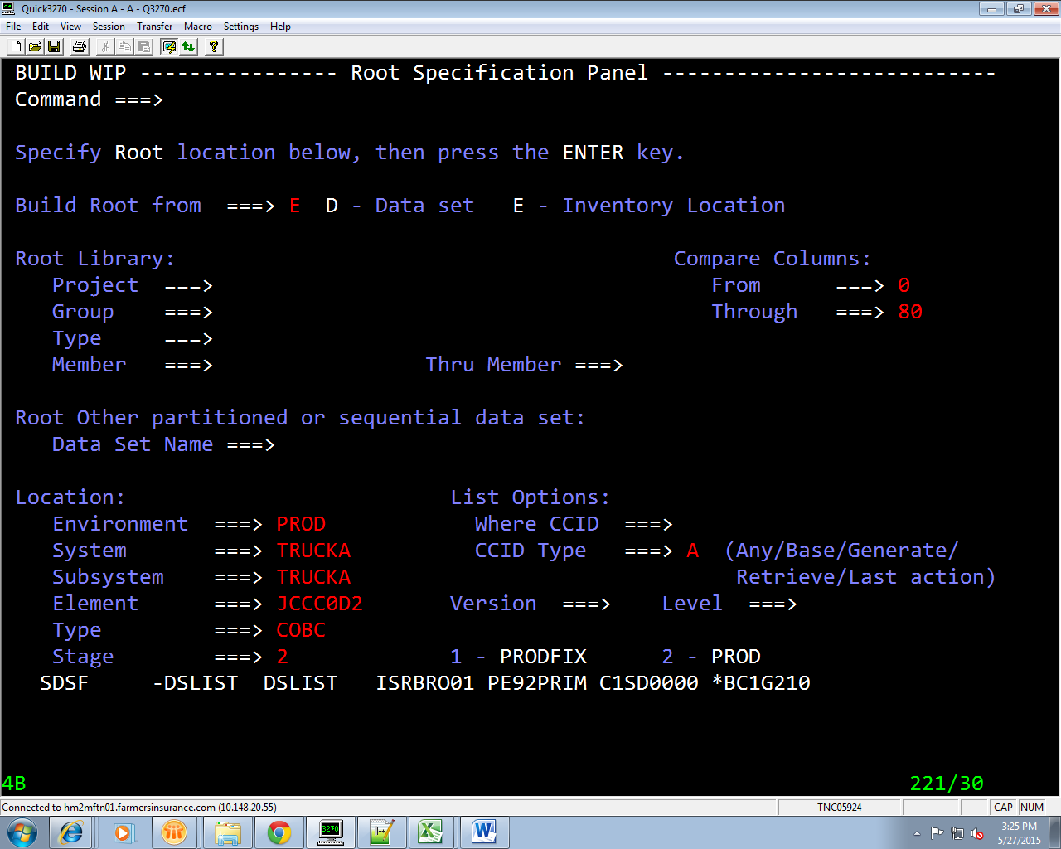

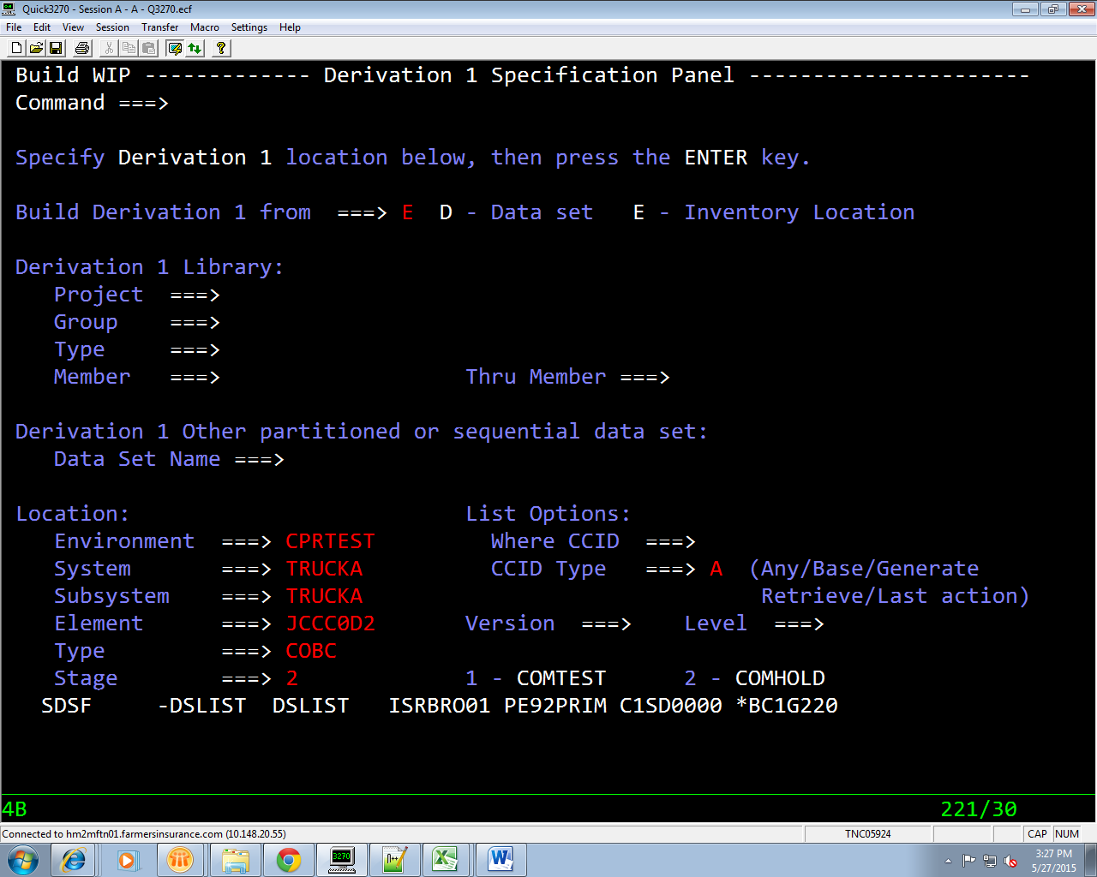

**After PRESSING enter check the pdm PDS say**

**CLST.D678301.PDM**

Give find **“% I”**

Give find **“% D”**